**Origami Jurassic Park**

Jurassic Park is 12” X 12 “and is surrounded by a **square electric wire fence** 1 “apart 12” high.

It contains an oval pond with an **origami Duck** (6X6 squares) (instructions are in “**origami duck.doc**”) in it and towards the end of the semester a particle system water fountain.

It contains an **origami Bunny** (6X6 squares) (instructions are in “**origami bunny.doc**”) and an **origami Apatosaurus** (7X7 squares) (instructions are in “**origami apatosauras.doc**”).

Picturesof the **Jurassic Park** from the **front**, **back**, **left**, **right**, **top**, and **isometric** are included below. Please observe the positions and proportions.

The **Jurassic Park** **front** view:

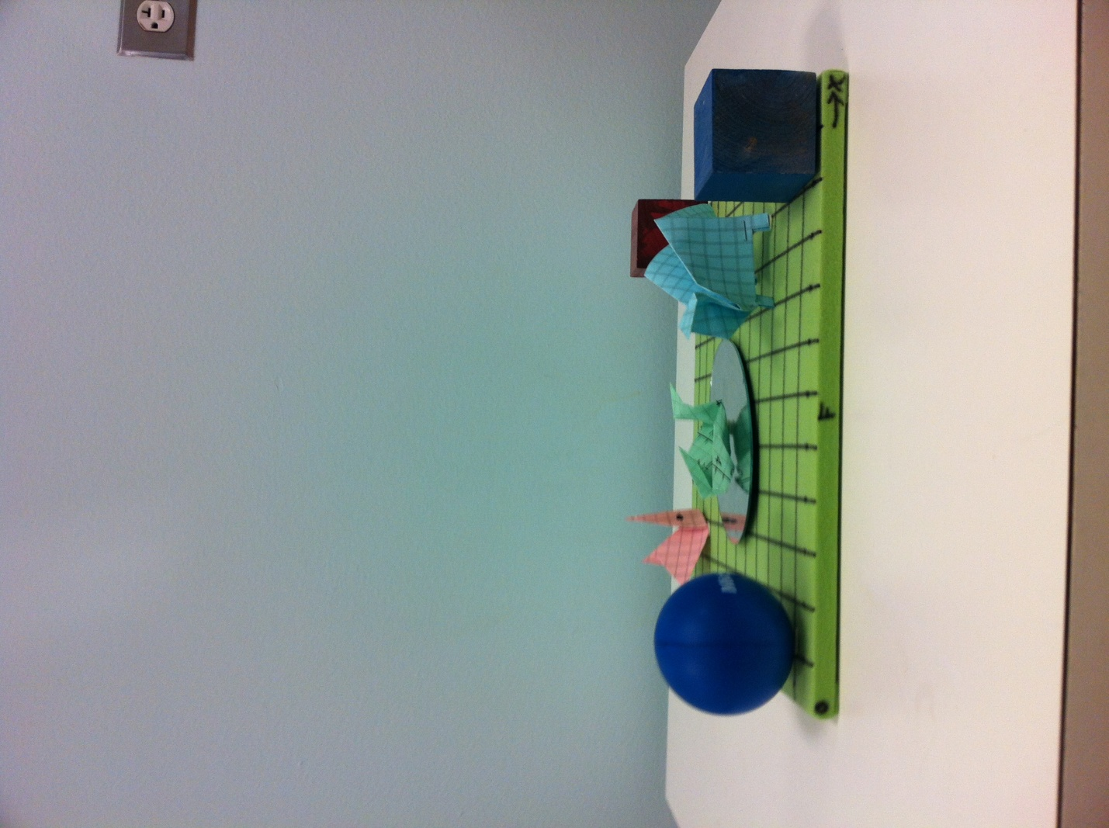

The **Jurassic Park** **right** view:

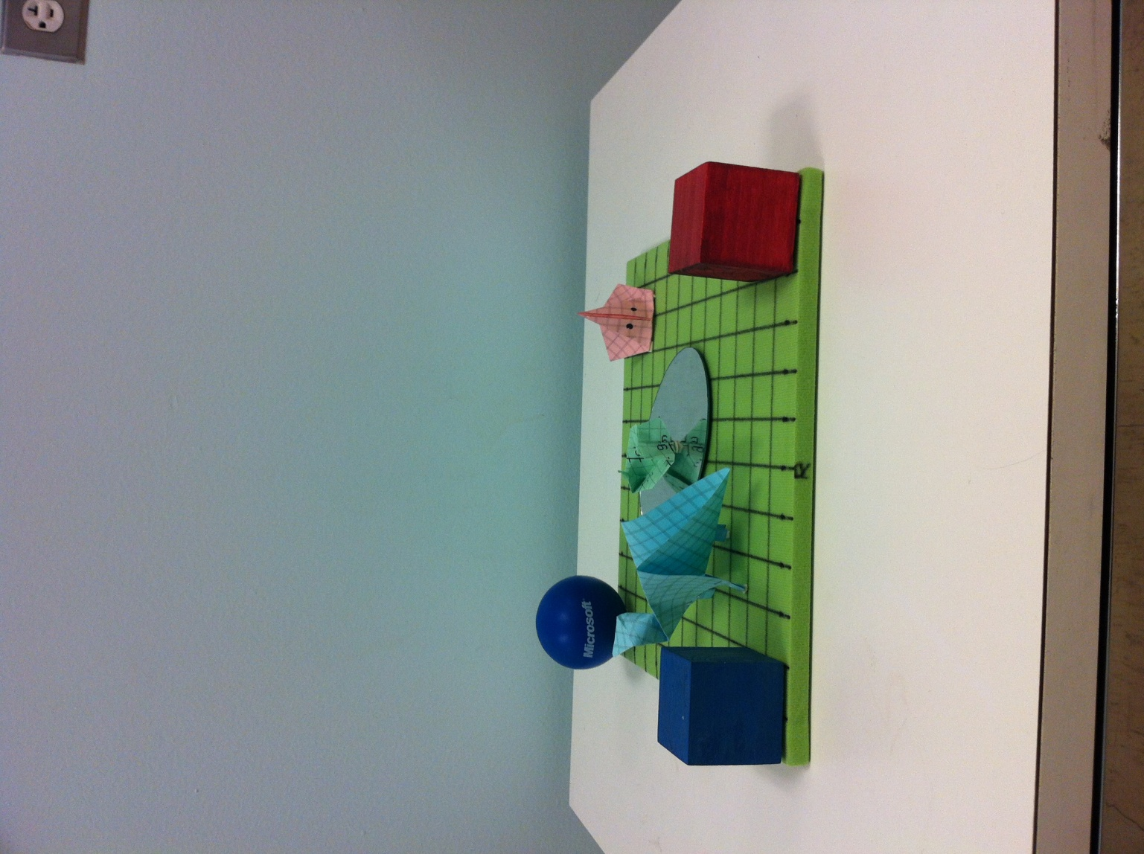

The **Jurassic Park** **back** view:

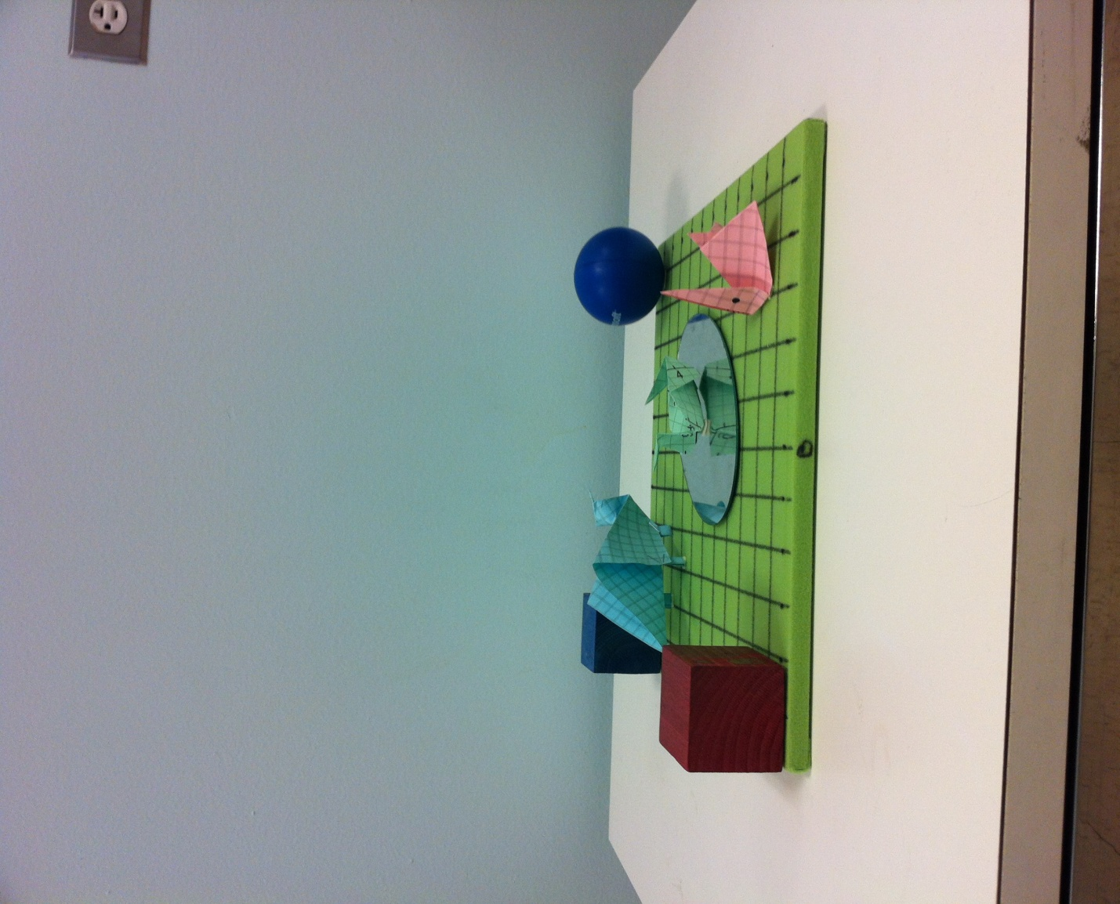

The **Jurassic Park** **left** view:

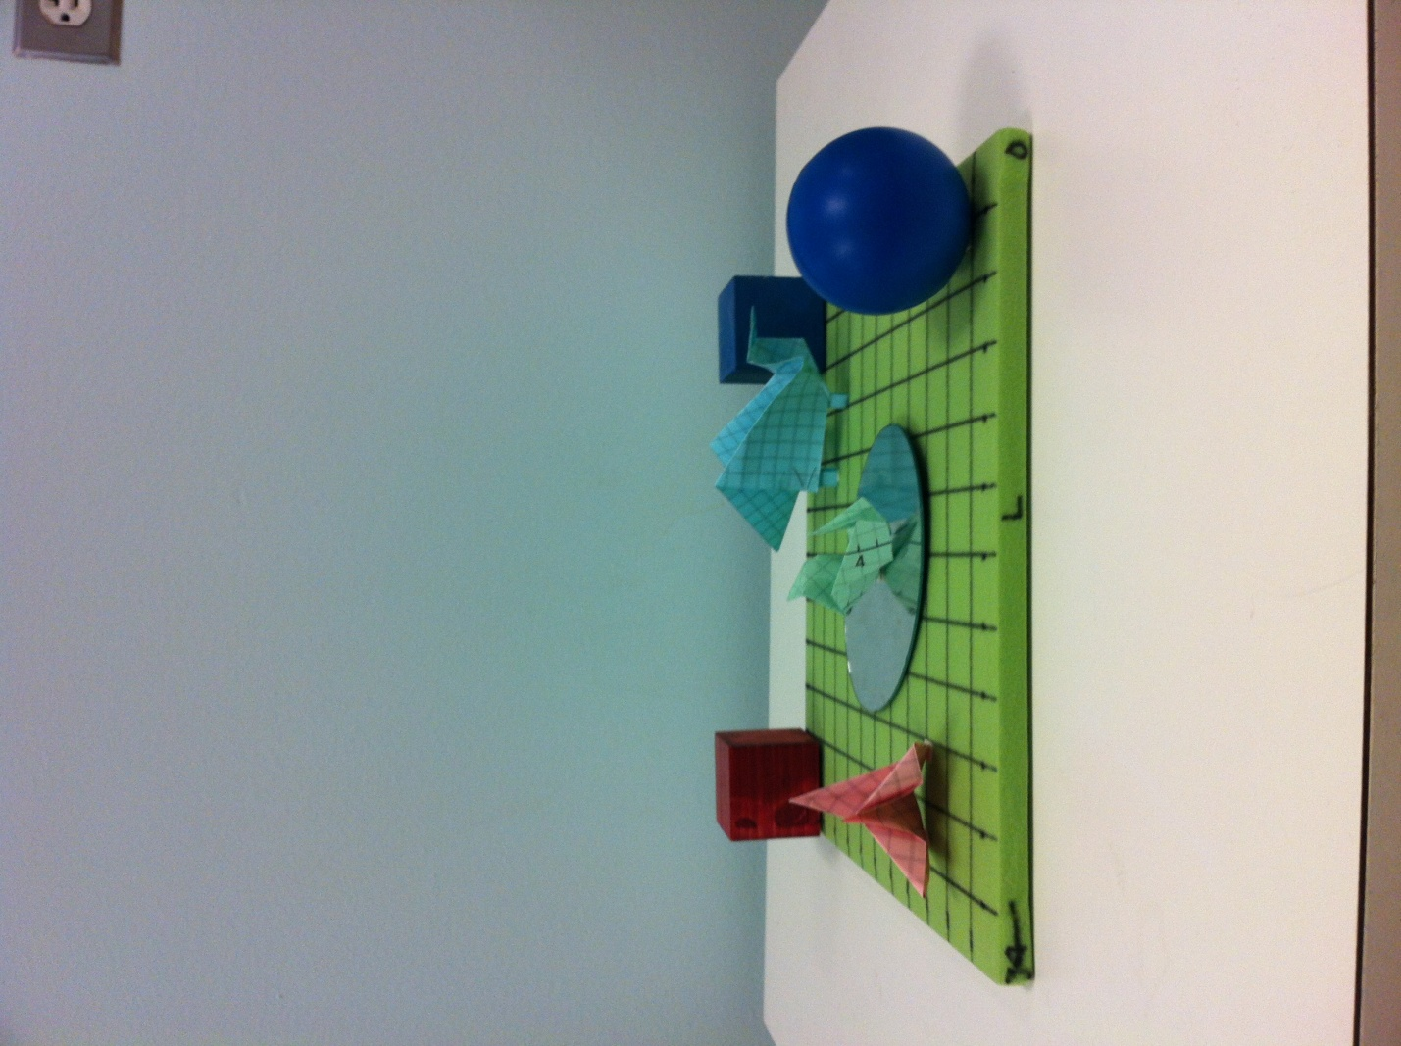

The **Jurassic Park** **top** view:

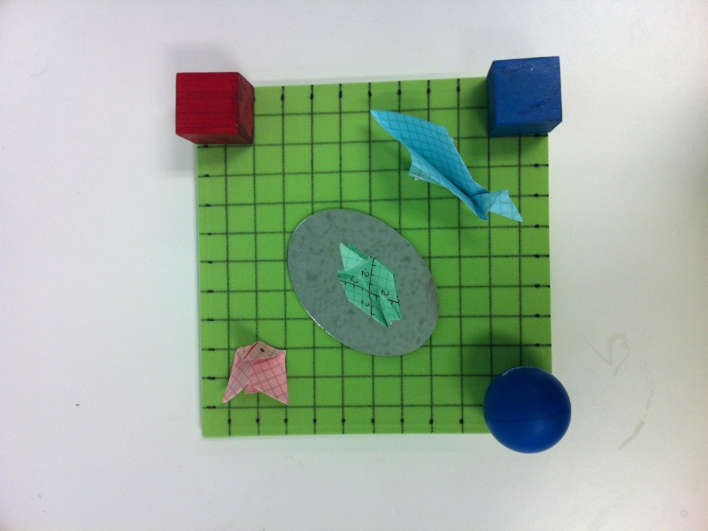

The **Jurassic Park** **isometric** view:

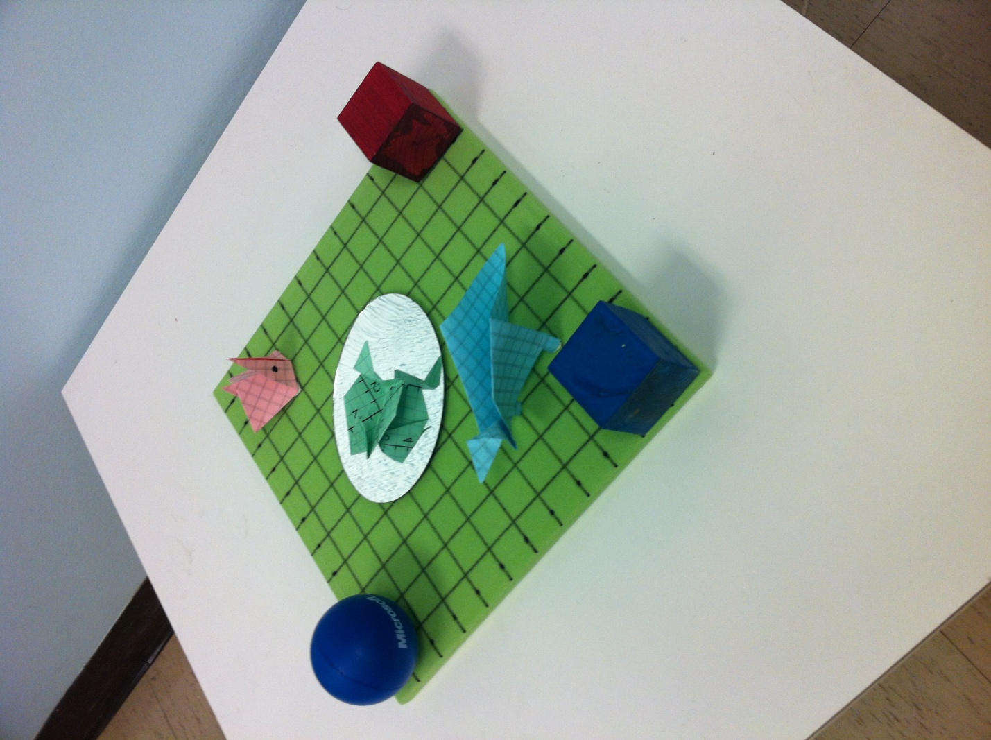

**PLEASE use the center of the Jurassic Park (the 12” X 12” board as the World Origin (0,0,0).**